HONG KONG INSTITUTE OF VOCATIONAL EDUCATION
Laboratory 7c: Tkinter

TASK:
1. Create the following Review Form GUI by using the pack layout manager. It is nice to create a base frame to hold the four frames such as title frame, author frame, review frame and button frame. All other widget such as labels, entry, text, and buttons, should be placed in the corresponding frames.
frm_base
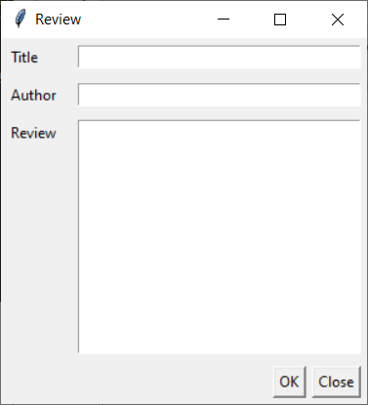
frm_title
frm_author
frm_button
frm_review
lbl_title, ent_title
lbl_author, ent_author
lbl_review, ent_review
btn_ok, btn_close
Answer:
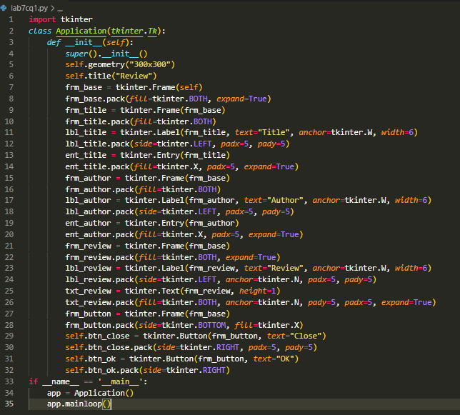

2. With reference from previous labs, rewrite the student registration form GUI by using the grid layout manager.

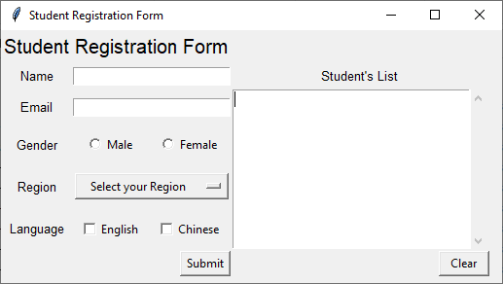
Row 0
Row 1
Row 2
Row 3
Row 4
Row 5
Row 6
Col 0
Col 1
Col 2
Col 3

Window geometry: 520x260
Padding for all rows and columns: 5

Answer:

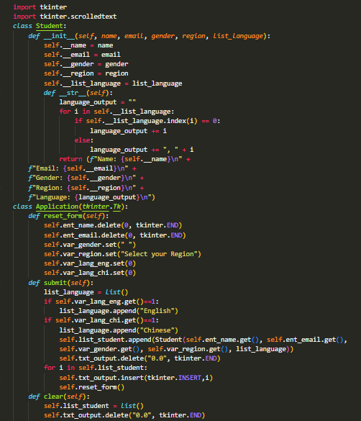

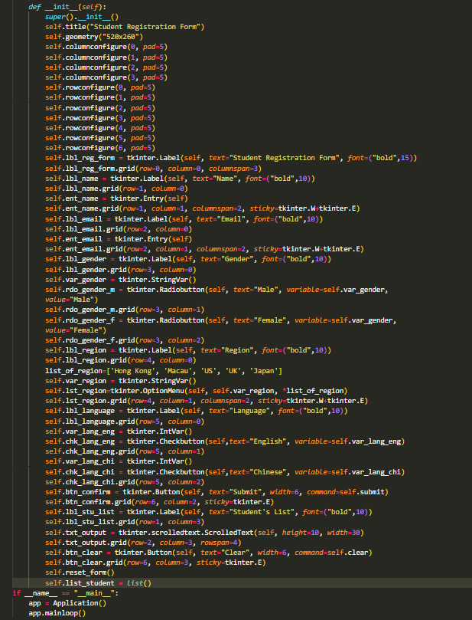

3. With reference from lecture notes and previous labs, rewrite the student registration form GUI by using multiple frames.
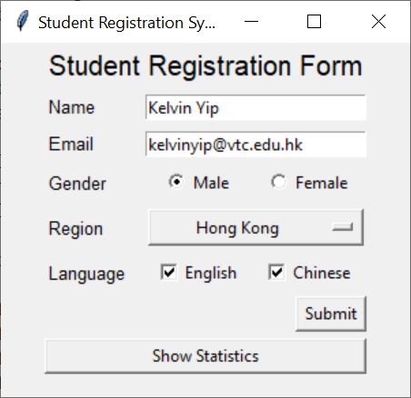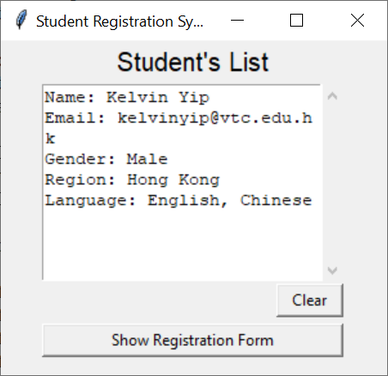

Answer:

